Name:Keerthika K

Reg.No:2019504033

IBM SMART HOME:
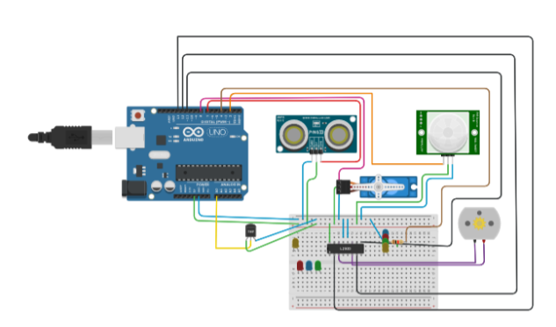

CODE:
#include<Servo.h>
const int pingPin = 7;
int servoPin = 8;

Servo servo1;

void setup() {
// initialize serial communication:
Serial.begin(9600);
servo1.attach(servoPin);
pinMode(2,INPUT);
pinMode(4,OUTPUT);
pinMode(11,OUTPUT);
pinMode(12,OUTPUT);
pinMode(13,OUTPUT);
pinMode(A0,INPUT);
digitalWrite(2,LOW);
digitalWrite(11,HIGH);

}

void loop() {

long duration, inches, cm;

pinMode(pingPin, OUTPUT);
digitalWrite(pingPin, LOW);
delayMicroseconds(2);
digitalWrite(pingPin, HIGH);
delayMicroseconds(5);
digitalWrite(pingPin, LOW);

// The same pin is used to read the signal from the PING))): a HIGH pulse
// whose duration is the time (in microseconds) from the sending of the ping
// to the reception of its echo off of an object.
pinMode(pingPin, INPUT);
duration = pulseIn(pingPin, HIGH);

// convert the time into a distance
inches = microsecondsToInches(duration);
cm = microsecondsToCentimeters(duration);

//Serial.print(inches);
//Serial.print("in, ");
//Serial.print(cm);
//Serial.print("cm");
//Serial.println();
//delay(100);

servo1.write(0);

if(cm < 40)
{
servo1.write(90);
delay(2000);
}
else
{
servo1.write(0);
}

// PIR with LED starts
int pir = digitalRead(2);

if(pir == HIGH)
{
digitalWrite(4,HIGH);
delay(1000);
}
else if(pir == LOW)
{
digitalWrite(4,LOW);
}

//temp with fan
float value=analogRead(A0);
float temperature=value*0.48;

Serial.println("temperature");
Serial.println(temperature);

if(temperature > 20)
{
digitalWrite(12,HIGH);
digitalWrite(13,LOW);
}
else
{
digitalWrite(12,LOW);
digitalWrite(13,LOW);
}
}

long microsecondsToInches(long microseconds) {
return microseconds / 74 / 2;
}

long microsecondsToCentimeters(long microseconds) {
return microseconds / 29 / 2;
}

